**Renzulli Learning**

**How Do I Get Started with Projects? -Teachers**

**Teachers Might Assign Projects to Students**

You can assign your students projects from the Teacher Dashboard by going to *Teach* on the menu and selecting *Projects*.

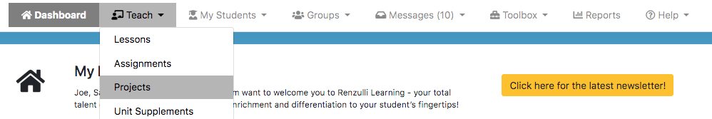

You can sort Super Starter Projects by Interest Area AND by Grade Level. Then assign a Super Starter Project to a group or an individual student.

